

NAME: ANUSHKA DUBEY
REGISTRATION NUMBER: 25BAI11284

Project: TO-DO LIST

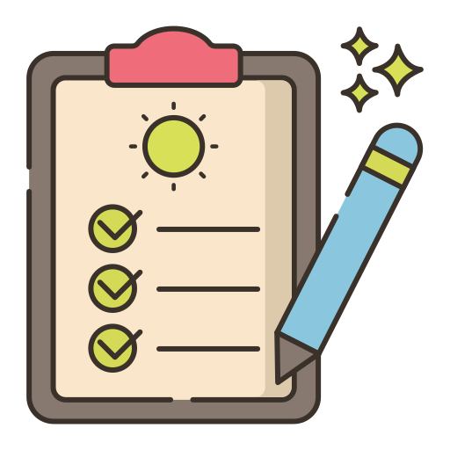

TABLE OF CONTENTS

S. No. | Title
1 | Introduction
2 | Problem Statements
3 | Functional and non-functional requirements
4 | System architecture
5 | Design diagrams
6 | Design decisions
7 | Implementation details
8 | Screenshots/results
9 | Testing approach
10 | Challenges faced
11 | Learnings
12 | Future enhancements
13 | References

Introduction

This project is a simple console-based To-Do List application developed in Python. The main objective of the program is to help students organize their academic tasks effectively during their college semester. By using basic Python concepts such as lists, functions, loops, and conditional statements, the application allows users to add tasks, view all tasks, remove tasks, and exit the program.
The program stores tasks in a list and provides a menu-driven interface where the user can interact by choosing options. Each function in the code is designed to handle a specific operation:
- Add Task: Lets the user input a new task, which is then stored in the list.
- View Tasks: Displays all tasks with numbering for easy reference.
- Remove Task: Allows the user to delete a task by selecting its number.
- Exit: Ends the program gracefully.
This project demonstrates how Python can be used to build practical applications that improve productivity. It is beginner-friendly, easy to understand, and can be extended further by adding features such as saving tasks to a file, setting deadlines, or marking tasks as completed.

PROBLEM STATEMENTS

1.Task Organization Challenge
College students often struggle to keep track of multiple academic tasks such as assignments, exam preparation, and project deadlines. Without a proper system, tasks may be forgotten or completed late.
- Lack of Simple Tools
Many productivity apps are either too complex or require internet access. Beginners in programming need a simple, offline tool that demonstrates how tasks can be managed effectively using basic coding concepts.
- Need for Practical Application of Python
First-semester students learning Python require projects that apply fundamental concepts (lists, loops, functions, conditionals) in a real-world scenario. A to-do list app provides a practical way to reinforce these skills.
- Difficulty in Task Prioritization
Without a structured list, students may find it hard to prioritize tasks. This project addresses the problem by allowing tasks to be added, viewed, and removed in an organized manner.

FUNCTIONAL AND NON-FUNCTIONAL REQUIREMENTS

FUNCTIONAL REQUIREMENTS:

•1. Add Task
  - The system must allow the user to add a new task to the list.
  - Each task should be stored in memory until removed or the program exits.
- View Tasks
  - The system must display all tasks currently in the list.
  - Tasks should be numbered for easy identification.
- Remove Task
  - The system must allow the user to delete a task by entering its number.
  - The system must validate the input and handle invalid task numbers gracefully.
- Exit Program
  - The system must provide an option to exit the application.
  - On exit, the program should terminate cleanly with a message.
- Menu Display
- The system must show a menu with options (Add, View, Remove, Exit) after each action.

NON-FUNCTIONAL REQUIREMENTS:

• 1. Usability
  - The program should have a simple, text-based interface that is easy for beginners to use.
  - Error messages should be clear and informative.
- Reliability
  - The program should handle invalid inputs (e.g., non-numeric task numbers) without crashing.
  - Tasks should remain in memory during the session until explicitly removed.
- Performance
  - The program should respond instantly to user commands since operations are lightweight.
  - It should handle a reasonable number of tasks (e.g., 50+) without slowing down.
- Maintainability
  - The code should be modular, with separate functions for each operation (add, view, remove).
  - Comments should explain the purpose of functions for easy understanding.
- Portability
- The program should run on any system with Python installed (Windows, macOS, Linux).

SYSTEM ARCHITECTURE

1. Overview
The system follows a modular architecture where each functionality (add, view, remove, exit) is implemented as a separate function. The program uses a menu-driven loop to continuously interact with the user until they choose to exit.
2. Components
- User Interface (Console I/O)
  - Displays the menu.
  - Accepts user input (choices and task details).
  - Shows output messages (confirmation, errors, task list).
- Task Storage (List Data Structure)
  - All tasks are stored in a Python list (tasks).
  - Tasks are added, viewed, and removed from this list during program execution.
  - Data is temporary (lost when program exits).
- Functional Modules (Functions)
  - show_menu() → Displays available options.
  - add_task() → Adds a new task to the list.
  - view_tasks() → Displays all tasks with numbering.
  - remove_task() → Deletes a task by its number.
- Control Flow (Main Loop)
- A while True loop keeps the program running.
- Based on user choice, the appropriate function is called.
- The loop ends when the user selects Exit.
3. Architecture Diagram (Textual Representation)
+-------------------+ | User (Console) | +-------------------+ | v +-------------------+ | Menu Display | <-- show_menu() +-------------------+ | v +-------------------+ +-------------------+ +-------------------+ | Add Task | | View Tasks | | Remove Task | | (add_task) | | (view_tasks) | | (remove_task) | +-------------------+ +-------------------+ +-------------------+ | | | v v v +--------------------------------+ | Task Storage (Python List) | | tasks = [] | +--------------------------------+

4. Execution Flow
- Program starts → show_menu() displays options.
- User selects an option → corresponding function executes.
- Functions interact with the task list (add/view/remove).
- Control returns to the menu until user exits.
5. Key Characteristics
- Simple & Modular: Each function handles one responsibility.
- Interactive: User communicates via console input/output.
- Temporary Storage: Tasks exist only during runtime.
- Extensible: Can be enhanced with file storage, deadlines, or priorities.

DESIGN DIAGRAMS
1. Use Case Diagram
Shows how the user interacts with the system.
+------------------+
| Student |
+------------------+
/ | \
/ | \
/ | \
v v v
+----------------+ +----------------+ +----------------+ +----------------+
| Add Task | | View Tasks | | Remove Task | | Exit Program |

2. Flowchart (Control Flow)
Represents the step-by-step execution of your program.
+-------------------+
| Start Program |
+-------------------+
|
v
+-------------------+
| Show Menu |
+-------------------+
|
v
+-------------------+
| User Choice? |
+-------------------+
/ | | \
v v v v
Add View Remove Exit
Task Tasks Tasks Program

3. Class Diagram (Conceptual)
Even though your code is function-based, you can show a conceptual class diagram for future scalability.
+-------------------+
| ToDoList |
+-------------------+
| - tasks: list |
+-------------------+
| + add_task() |
| + view_tasks() |
| + remove_task() |
| + show_menu() |

4. Data Flow Diagram (DFD – Level 0)
Shows how data moves between user, functions, and storage.
User -----> [Menu] -----> [Add Task] -----> Task List
| | |
| v v
| [View Tasks] <---- Task List
| |
| v
| [Remove Task] ----> Task List
|
v
Exit Program

DESIGN DECISION
•1. Programming Language Choice (Python)
  - Python was chosen because it is beginner-friendly, widely used in academia, and supports rapid prototyping.
  - Its simple syntax makes it easy to implement basic features like lists, loops, and functions.
- Data Structure (List for Task Storage)
  - Tasks are stored in a Python list (tasks) because lists allow dynamic addition and removal of items.
  - This choice keeps the program lightweight and easy to understand for first-semester students.
3. Function-Based Modular Design
  - Each operation (add, view, remove, show menu) is implemented as a separate function.
  - This modular approach improves readability, maintainability, and makes future enhancements easier.
4.Menu-Driven User Interface (Console I/O)
  - A text-based menu was used to keep the interface simple and accessible.
  - Console input/output ensures the program runs on any system without requiring external libraries or GUIs.
- Control Flow (Infinite Loop with Exit Option)
  - A while True loop keeps the program running until the user explicitly chooses to exit.
  - This design ensures continuous interaction without restarting the program after each action.
6. Error Handling (Input Validation)
  - The program uses try-except blocks to handle invalid inputs when removing tasks.
  - This prevents crashes and improves reliability for beginner users.
7.Scalability Consideration
- Although tasks are stored only in memory, the design allows easy extension to file storage or databases later.
- The modular structure supports adding features like deadlines, priorities, or task completion status.

IMPLEMENTATION DETAILS
1. Task Storage
- A Python list named tasks is used to store all tasks.
- Lists are chosen because they allow easy addition (append) and removal (pop) of items dynamically.
tasks = []
2. Menu Display
- The show_menu() function prints the available options (Add, View, Remove, Exit).
- This provides a simple text-based interface for user interaction.
def show_menu():
print("\n--- College To-Do List ---")
print("1. Add Task")
print("2. View Tasks")
print("3. Remove Task")
print("4. Exit")
3. Adding a Task
- The add_task() function takes user input and appends it to the tasks list.
- A confirmation message is displayed after successful addition.
def add_task(): task = input("Enter the task: ") tasks.append(task) print(f" Task '{task}' added!")
4. Viewing Tasks
- The view_tasks() function checks if the list is empty.
- If tasks exist, it displays them with numbering using enumerate().
- This helps the user identify tasks easily.
def view_tasks(): if not tasks: print(" No tasks yet!") else: print("\nYour Tasks:") for i, task in enumerate(tasks, start=1): print(f"{i}. {task}")
5. Removing a Task
- The remove_task() function first calls view_tasks() to show current tasks.
- The user enters the task number to remove.
- Input validation is handled using try-except to avoid crashes if the user enters invalid data.
def remove_task(): view_tasks() if tasks: try: task_num = int(input("Enter task number to remove: ")) removed = tasks.pop(task_num - 1) print(f" Task '{removed}' removed!") except (ValueError, IndexError): print(" Invalid task number!")
6. Main Control Loop
- A while True loop keeps the program running until the user chooses to exit.
- Based on the user’s choice, the corresponding function is called.
- If the user enters an invalid option, an error message is shown.
while True: show_menu() choice = input("Choose an option (1-4): ") if choice == "1": add_task() elif choice == "2": view_tasks() elif choice == "3": remove_task() elif choice == "4": print(" Exiting To-Do List. Good luck with your semester!") break else: print(" Invalid choice, try again.")

RESULTS:
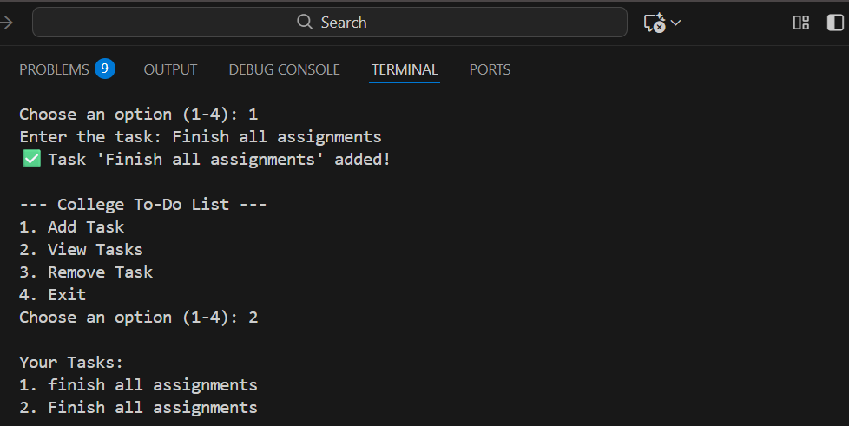
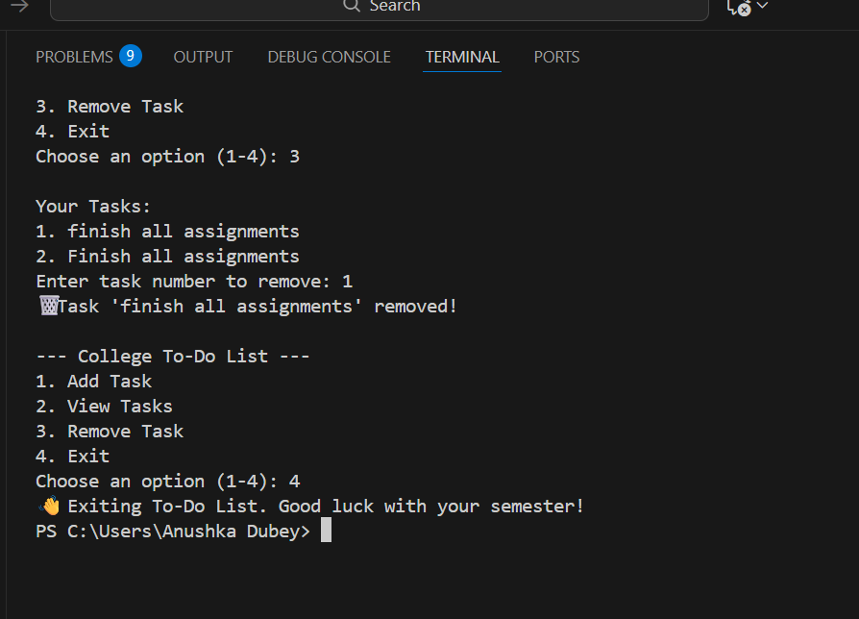

TESTING APPROACH
1. Testing Objectives
- Ensure all core functionalities (Add, View, Remove, Exit) work as expected.
- Validate that the program handles invalid inputs gracefully.
- Confirm that the user interface (menu-driven console) is clear and responsive.
2. Types of Testing
- Unit Testing
  - Test each function (add_task(), view_tasks(), remove_task(), show_menu()) individually.
  - Example: Verify that add_task() correctly appends a new task to the list.
• Integration Testing
  - Test how functions work together in the main loop.
  - Example: Add multiple tasks, then view and remove them to ensure consistency.
- Functional Testing
  - Check that all menu options perform their intended operations.
  - Example: Choosing option “2” should always display the current task list.
- Negative Testing (Error Handling)
  - Provide invalid inputs (e.g., letters instead of numbers when removing tasks).
  - Ensure the program displays error messages without crashing.
- Usability Testing
- Verify that the menu is easy to understand and that instructions are clear for beginners.
- 3. Test Scenarios
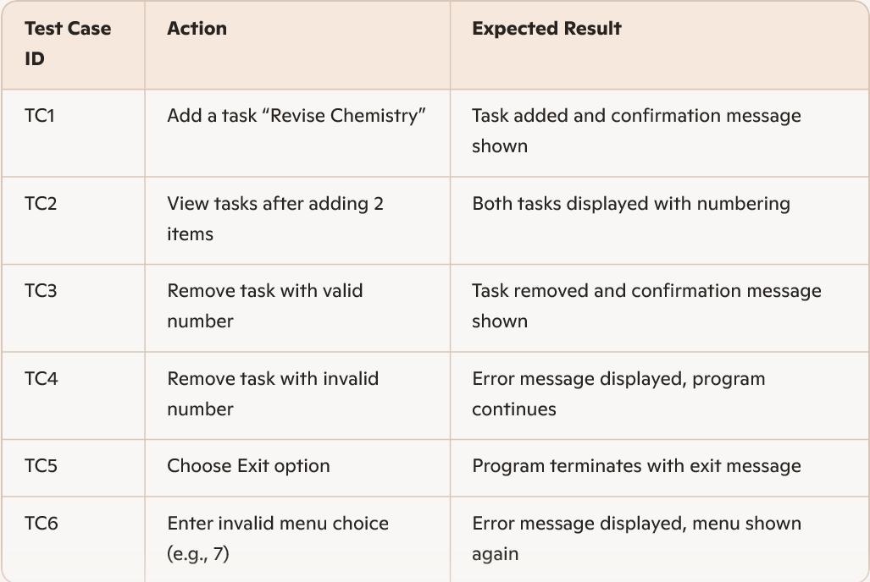
4. Tools & Methods
- Manual Testing: Run the program in the console and manually input test cases.
- Automated Testing (Optional): Use Python’s unittest module to write test cases for functions.
5. Acceptance Criteria
- All valid operations must execute correctly.
- Invalid inputs must not crash the program.
- The user must be able to manage tasks smoothly during a session.

CHALLENGES FACED
1.• Data Persistence
  - Tasks are stored only in memory (Python list).
  - Once the program exits, all tasks are lost.
  - Challenge: figuring out how to save tasks permanently (e.g., using files or databases).
- Input Validation
  - Users may enter invalid inputs (letters instead of numbers, wrong task numbers).
  - Handling these errors without crashing required careful use of try-except.
- User Interface Limitations
  - The program uses a text-based console interface.
  - Beginners may find it less intuitive compared to graphical apps.
  - Challenge: keeping the menu simple and clear.
• 4. Scalability
  - The current design works well for small lists.
  - Managing a large number of tasks (50+) could make the console output cluttered.
  - Challenge: designing a way to organize or filter tasks.
5.Code Modularity
  - As a beginner, structuring the program into functions was a learning curve.
  - Challenge: deciding which parts of the code should be separate functions for clarity.
6.Error Handling for Removal
  - Removing tasks by number required careful indexing.
  - Challenge: ensuring that invalid numbers don’t break the program.
7.Extensibility
- Adding features like deadlines, priorities, or completion status requires redesign.
- Challenge: balancing simplicity with the desire to add advanced features.

LEARNINGS
• Understanding Python Basics
  - Practiced using variables, lists, loops, and conditional statements.
  - Learned how to structure a program with multiple functions.
- Modular Programming
  - Gained experience in breaking a problem into smaller functions (add_task(), view_tasks(), remove_task(), show_menu()).
  - Understood how modularity improves readability and maintainability.
- User Interaction (Console I/O)
  - Learned how to take input from users using input() and display output using print().
  - Designed a simple menu-driven interface for smooth user experience.
- Data Handling with Lists
  - Understood how lists can store multiple tasks dynamically.
  - Practiced adding (append) and removing (pop) items from a list.
•5. Error Handling
  - Learned how to use try-except blocks to manage invalid inputs.
  - Improved program reliability by preventing crashes when users enter wrong values.
6.Control Flow Management
  - Implemented a continuous loop (while True) to keep the program running until the user exits.
  - Practiced decision-making with if-elif-else statements.
7.Problem-Solving Skills
  - Learned how to translate real-world needs (task management) into a working program.
  - Improved logical thinking by designing step-by-step solutions.
• 8. Scalability Awareness
- Realized that while the program works for basic needs, it can be extended with features like deadlines, priorities, or file storage.
- Understood the importance of designing code that can grow with future requirements.

FUTURE ENHANCEMENTS
• 1. Data Persistence (File Storage / Database)
  - Currently, tasks are stored only in memory and lost when the program exits.
  - Future enhancement: Save tasks to a text file, JSON file, or database so they remain available across sessions.
- Task Prioritization
  - Add options to mark tasks as High, Medium, or Low priority.
  - This will help students focus on the most important tasks first.
- Deadlines and Reminders
  - Allow users to set due dates for tasks.
  - Future versions could integrate reminders or alerts for upcoming deadlines.
•4. Task Completion Status
  - Add functionality to mark tasks as Completed or Pending.
  - This helps track progress and motivates users.
5.Search and Filter Options
  - Enable searching tasks by keywords.
  - Add filters to view only pending tasks, completed tasks, or high-priority tasks.
6.Graphical User Interface (GUI)
  - Upgrade from console-based interface to a GUI using libraries like Tkinter or PyQt.
  - This would make the app more user-friendly and visually appealing.
7.Multi-User Support
  - Allow multiple users to maintain separate task lists.
  - Useful for group projects or shared academic planning.
• 8. Cloud Integration
  - Sync tasks with cloud services (Google Drive, OneDrive) for access across devices.
  - This makes the app more practical for real-world use.
9.Mobile App Version
  - Extend the project into a mobile app using frameworks like Kivy or Flutter (with Python backend).
  - Students could manage tasks on the go.
10.Analytics and Progress Tracking
- Provide statistics such as number of tasks completed per week.
- Visualize progress with charts to motivate users.

REFERENCES
In order to work on this project titled- Educational Technology(EdTech), the following books and websites are referred by me during the various phases of development of the project.
    - www.youtube.com
    - www.python.com
Other than the mentioned thing, I have also seeked help and information from my teachers who made me understand each and every detail of the project.
Key features of the project:
. Menu- driven interface
. Task management
. Error handling
. Continuous interaction

